##### The Parish of Christ Church

Padgate

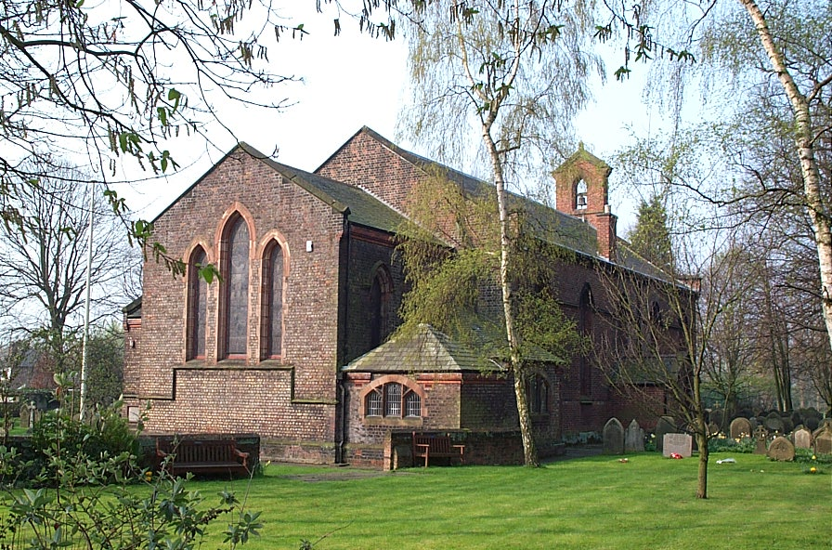

John Stubbings

Wednesday 27th February 2013

# Order of Service

#### **Introduction**

**All:** **Merciful Father, hear our prayers and comfort us; renew our trust in your Son, whom you raised from the dead; strengthen our faith that all who have died in the love of Christ will share in his resurrection; who lives and reigns with you, in the unity of the Holy Spirit, one God, now and for ever.**  **Amen**

**Hymn:** The Lord's my Shepherd, I'll not want;

he makes me down to lie -

in pastures green; he leadeth me -

the quiet waters by.

My soul he doth restore again,

and me to walk doth make -

within the paths of righteousness,

e'en for his own name's sake.

Yea, though I walk through death's dark vale,

yet will I fear no ill;

for thou art with me, and thy rod -

and staff me comfort still.

My table thou hast furnished

in presence of my foes;

my head thou dost with oil anoint ,

and my cup overflows.

Goodness and mercy all my life

shall surely follow me;

and in God's house, for evermore

my dwelling place shall be.

**The Scriptural Reading John 14. 1-6**

**The Eulogy** including tributes by members of John’s family

**Reflection:**  ‘Love me tender’ by Elvis Presley

**The Prayers and Lord’s Prayer:**

## Each section concludes:

Lord, in your mercy

***All: hear our prayer.***

## After the final section:

**God of mercy, entrusting into your hands all that you have made and rejoicing in our communion with all your faithful people, we make our prayers through Jesus Christ our Saviour. Amen.**

All: Our Father...

**Hymn:** Morning has broken like the first morning,

Blackbird has spoken like the first bird,

Praise for the singing. Praise for the morning.

Praise for them, springing fresh from the Word

Sweet the rain's new fall sunlit from heaven,

Like the first dewfall on the first grass.

Praise for the sweetness of the wet garden,

Sprung in completeness where his feet pass.

Mine is the sunlight. Mine is the morning

Born of the one light Eden saw play.

Praise with elation, praise every morning,

God’s re-creation of the new day.

**The Commendation**

All: Heavenly Father, in your Son Jesus Christ you have given us a true faith and a sure hope. Strengthen this faith and hope in us all our days, that we may live as those who believe in the communion of saints, the forgiveness of sins and the resurrection to eternal life; through Jesus Christ our Lord. Amen.

Acknowledgement: *Common Worship: Pastoral Services,* material from which is included in this service, is copyright © The Archbishops’ Council (2000)